**Supplementary Material-5: River plots for the pathway enrichment analysis on the top-500 genes from BDL-SP model**

In each of the sanky plot shown below, both pale golden and orange ribbon means significant p-adjusted value (<0.05); orange refers to more significant and pale golden colour refers to less significant. Grey colour ribbon means non-significant (p-adjusted value >0.05).

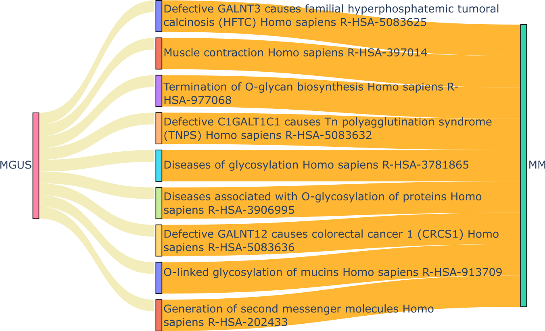

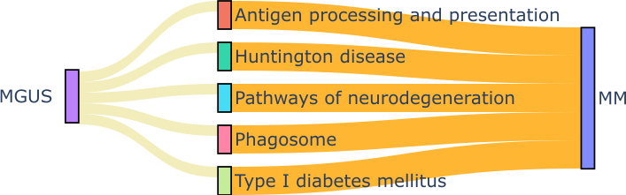

Figure-1: (A) KEGG Pathways that gained more significance during progression from MGUS to MM. (B) Reactome Pathways that gained more significance during progression from MGUS to MM.

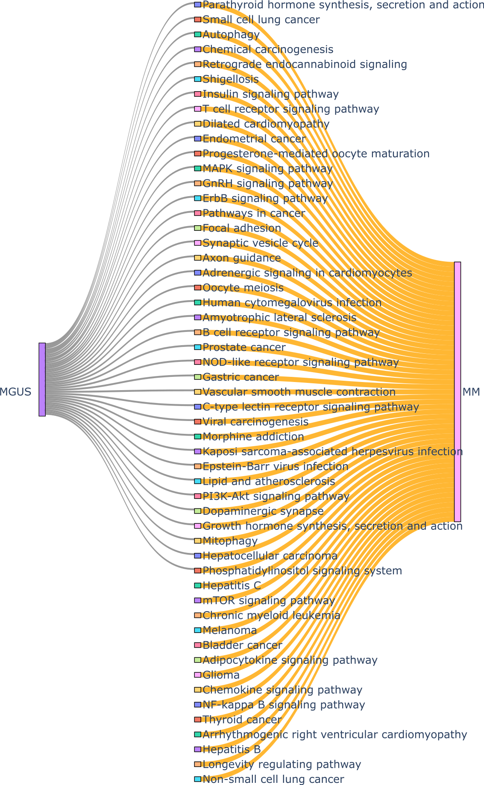

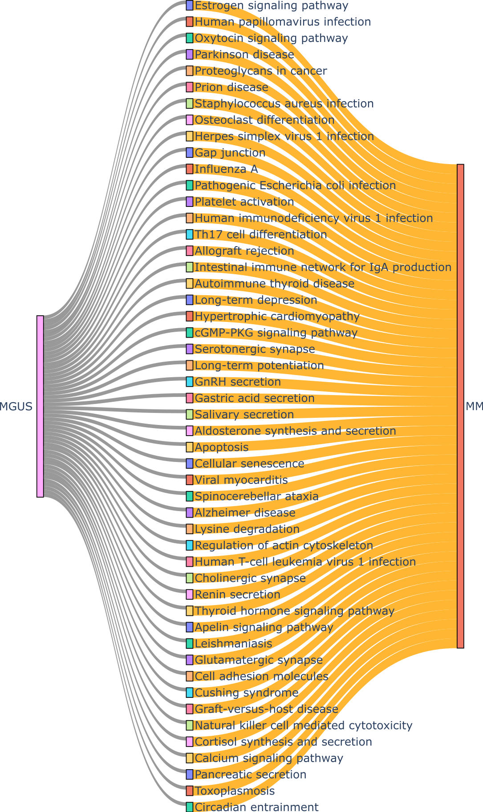

Figure-3: KEGG Pathways that uniquely significant in MM

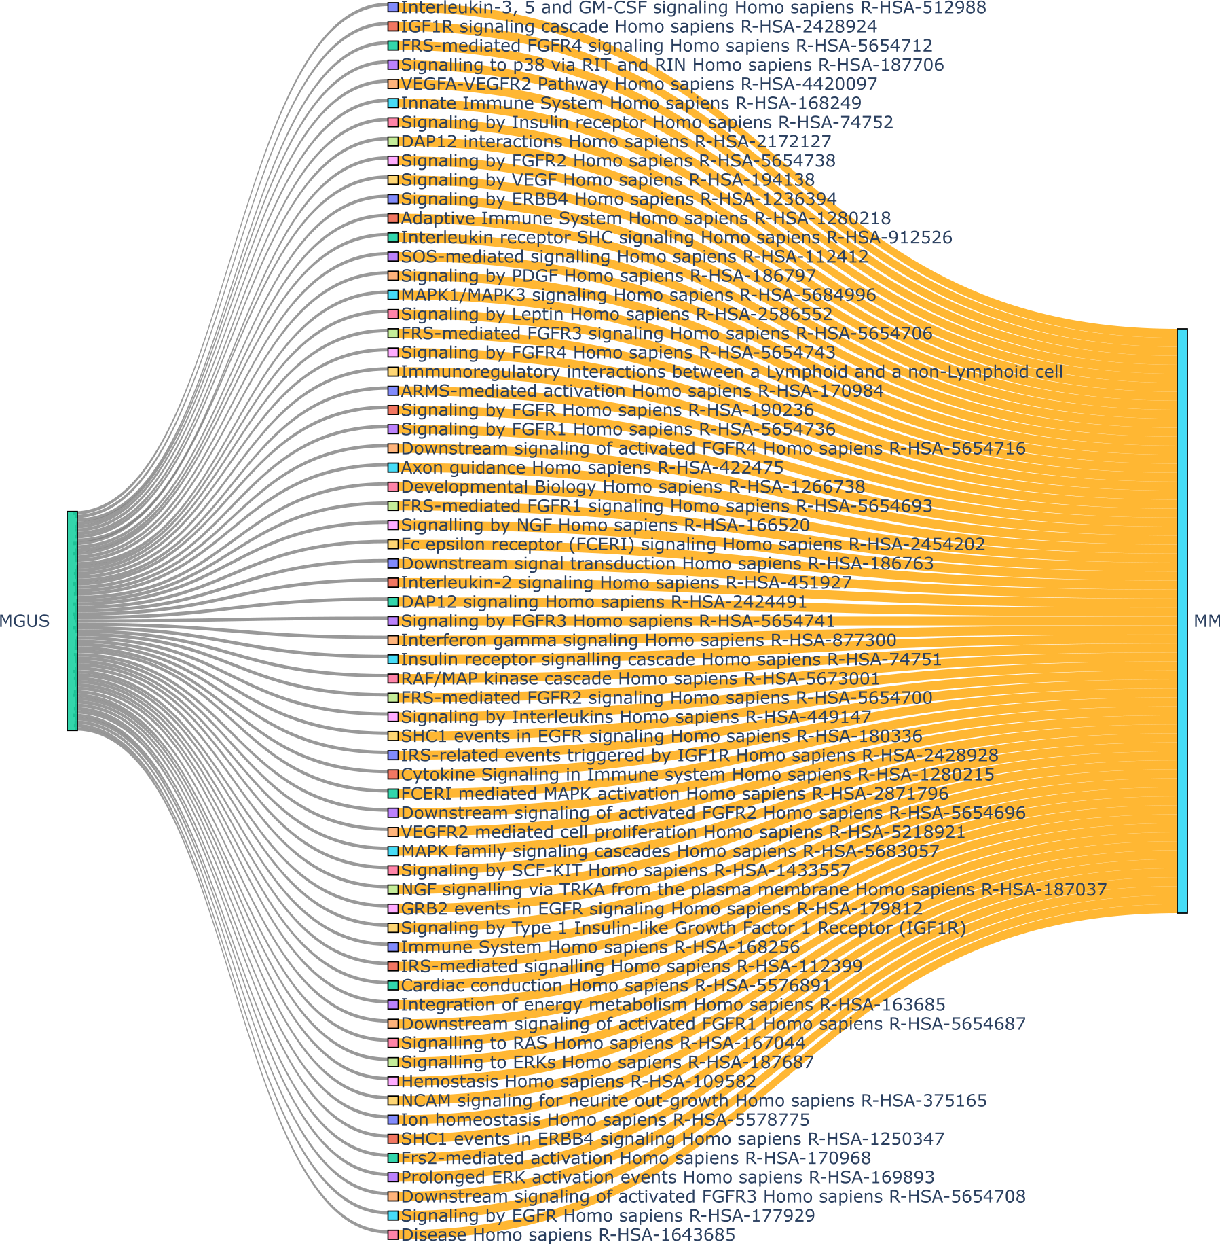

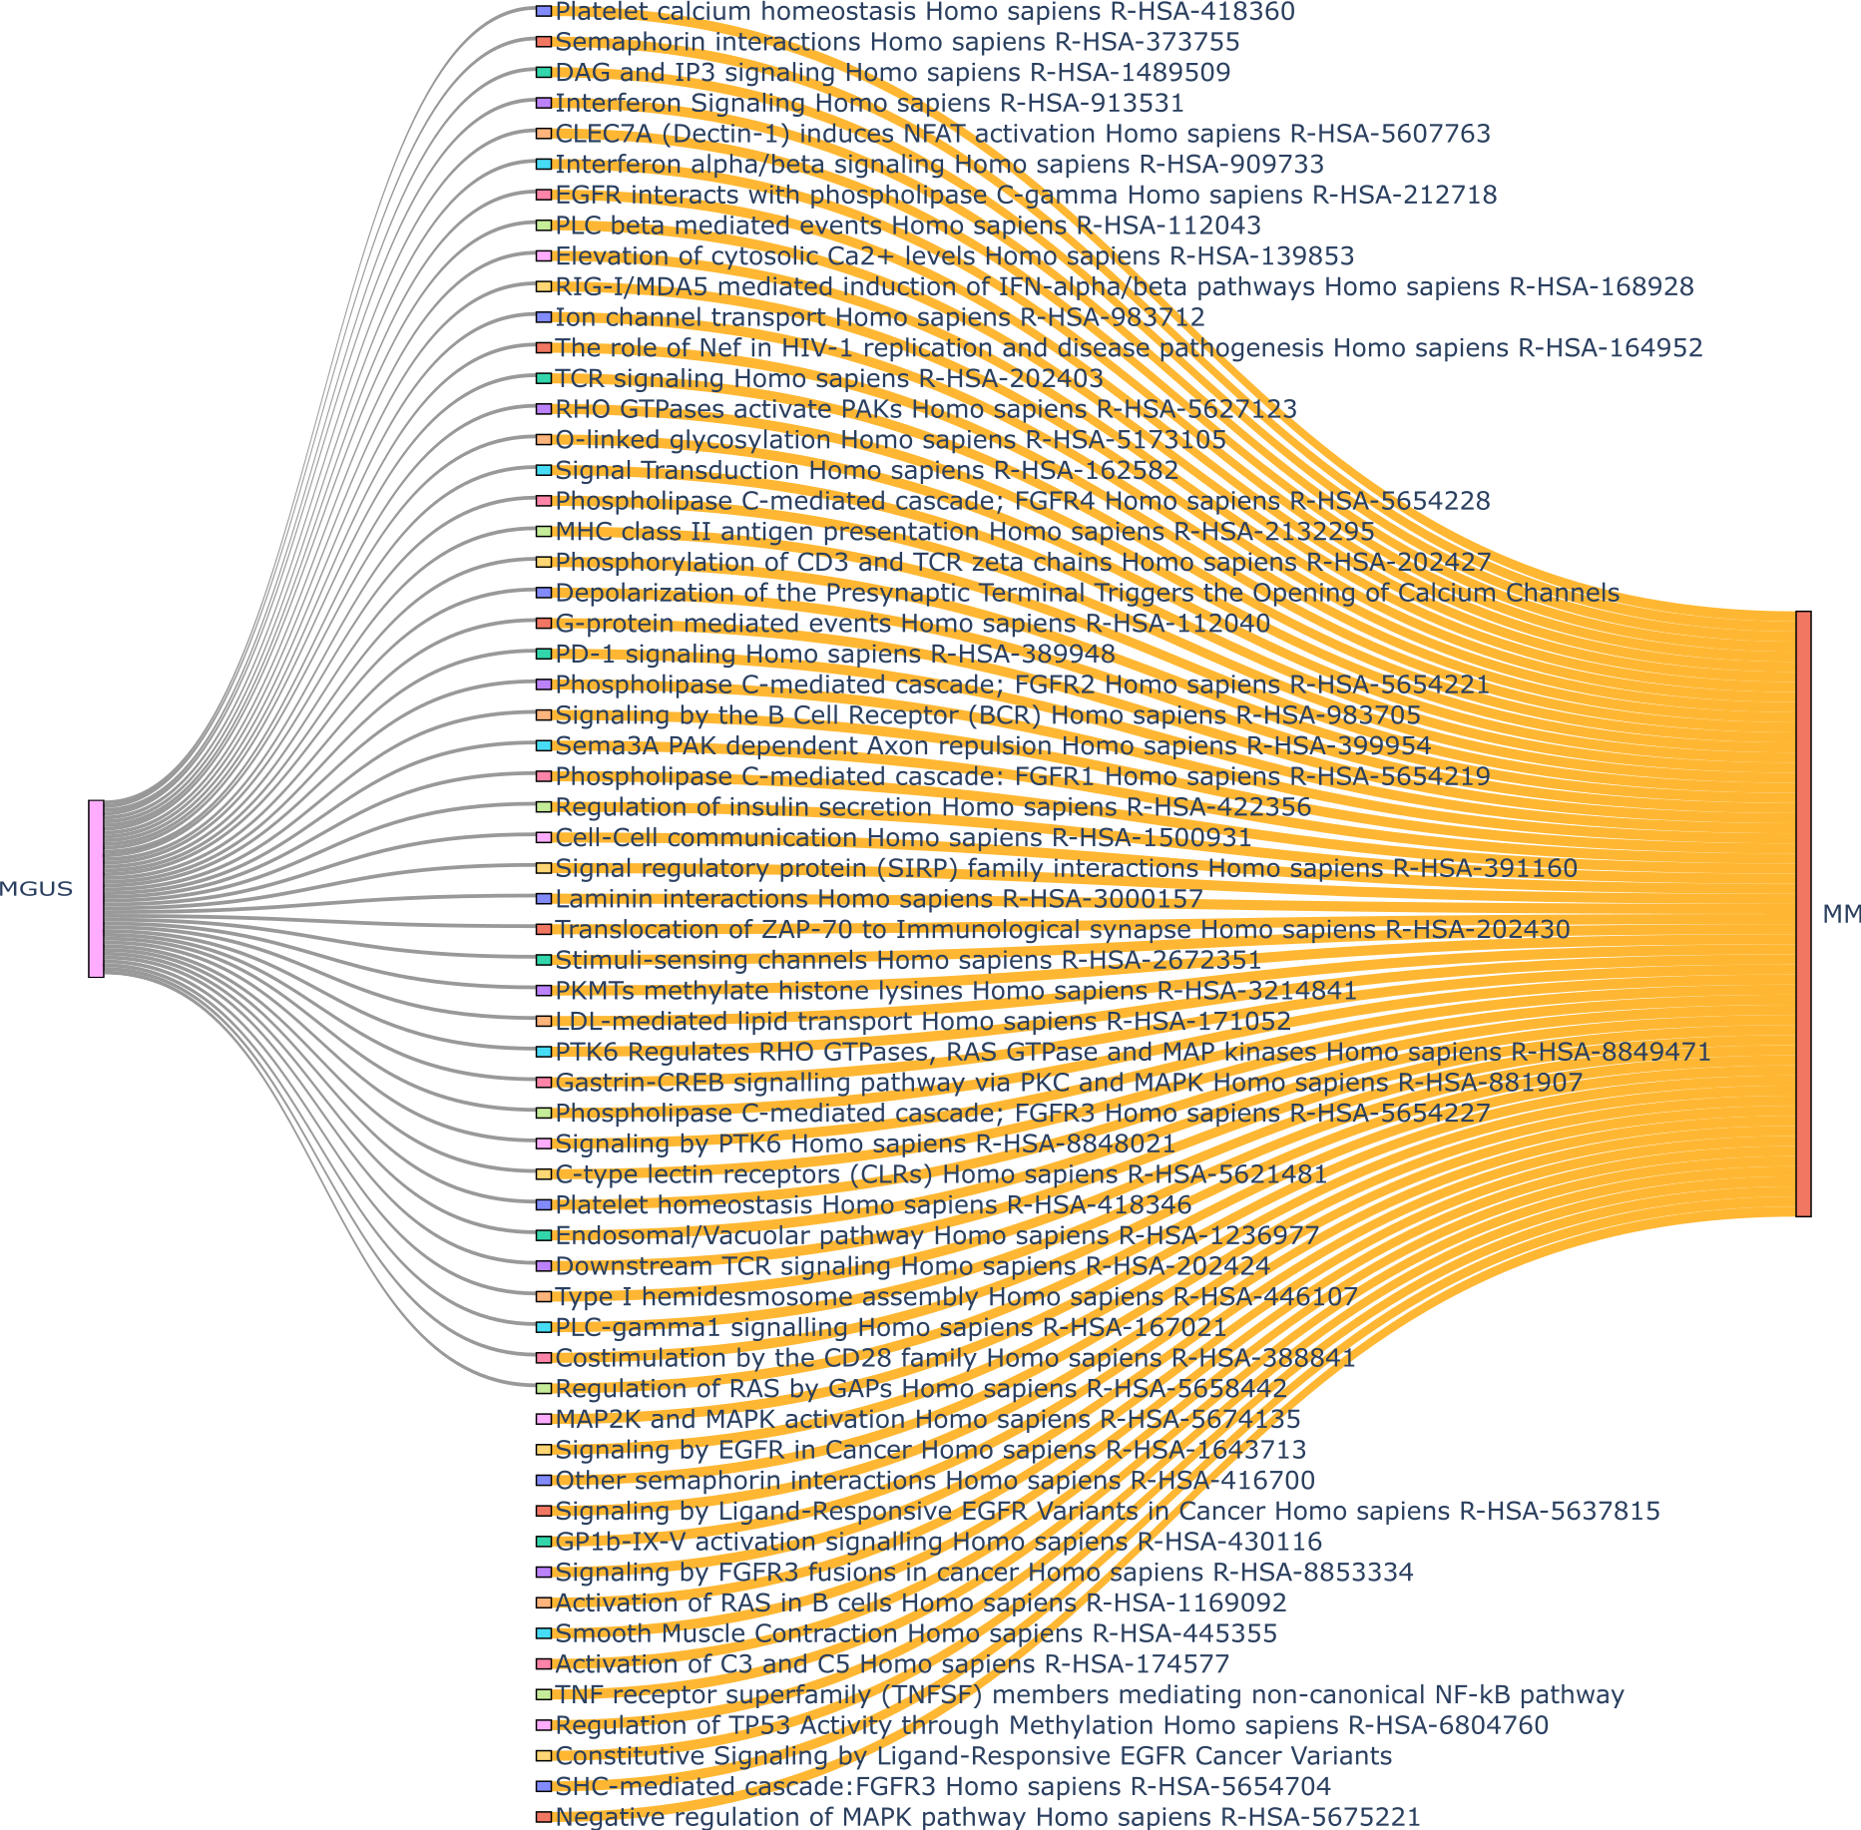

Figure-4:Reactome Pathways that uniquely significant in MM



Figure-5: Reactome Pathways that uniquely significant in MGUS